**Project Title**: Product Sales Analysis

**Phase 1:**Project Definition and Design Thinking

**Project Definition:** The project involves using IBM Cognos to analyze sales data and extract insights about top selling products, peak sales periods, and customer preferences. The objective is to help businesses improve inventory management and marketing strategies by understanding sales trends and customer behavior. This project includes defining analysis objectives, collecting sales data, designing relevant visualizations in IBM Cognos, and deriving actionable insights.

**PROJECT OBJECTIVE:**

The project objective in product sales analysis typically revolves around gaining insights into the performance and dynamics of a company's product sales. Here are some specific objectives that such a project might aim to achieve

**Sales Performance Evaluation:**

Analyze overall sales performance to understand how well products are selling.

Identify high-performing and low-performing products.

**Market Trends and Patterns:**

Identify market trends and patterns related to product sales.

Determine the factors influencing sales fluctuations.

**Customer Segmentation:**

Segment customers based on purchasing behavior and preferences.

Understand which products appeal to different customer segments.

**Geographical Analysis:**

Analyze product sales across different regions.

Identify regional preferences and adjust strategies accordingly.

**Customer Lifetime Value (CLV):**

Calculate and analyze the CLV to understand the long-term value of customers.

Focus on retaining high-value customers.

**Forecasting and Prediction:**

Use historical sales data for forecasting future sales.

Improve demand forecasting to enhance inventory planning.

**Digital Marketing Impact:**

Analyze the impact of digital marketing efforts on product sales.

Optimize online channels for better sales performance.

**Data Visualization:**

Present key findings through data visualizations to facilitate decision-making.

Create dashboards for ongoing monitoring of sales metrics.

**Python Libraries:**

Specify the python libraries you plan to use for data analysis

and modeling(eg.pandas,numpy,matplotlib)

**DATA SOURCE:**

Dataset link:

(<https://www.kaggle.com/datasets/ksabishek/product-sales-data>)

**PROGRAM:**

**import pandas as pd**

**import numpy as np**

**import matplotlib.pyplot as plt**

**import seaborn as sns**

**%matplotlib inline**

**import warnings**

**warnings.filterwarnings("ignore")**

**data = pd.read_csv('/kaggle/input/product-sales-data/statsfinal.csv')**

**data.head(-1)**

**OUT:**

|  |  |  |  |  |  |  |  |  |  |  |
| --- | --- | --- | --- | --- | --- | --- | --- | --- | --- | --- |
| Unnamed: 0 | Date | Q-P1 | Q-P2 | Q-P3 | Q-P4 | S-P1 | S-P2 | S-P3 | S-P4 |  |
| 0 | **0** | **13-06-2010** | **5422** | **3725** | **576** | **907** | **17187.74** | **23616.50** | **3121.92** | **6466.91** |
| 1 | **1** | **14-06-2010** | **7047** | **779** | **3578** | **1574** | **22338.99** | **4938.86** | **19392.76** | **11222.62** |
| 2 | **2** | **15-06-2010** | **1572** | **2082** | **595** | **1145** | **4983.24** | **13199.88** | **3224.90** | **8163.85** |
| 3 | **3** | **16-06-2010** | **5657** | **2399** | **3140** | **1672** | **17932.69** | **15209.66** | **17018.80** | **11921.36** |
| 4 | **4** | **17-06-2010** | **3668** | **3207** | **2184** | **708** | **11627.56** | **20332.38** | **11837.28** | **5048.04** |
| ... | **...** | **...** | **...** | **...** | **...** | **...** | **...** | **...** | **...** | **...** |
| 4594 | **4594** | **29-01-2023** | **1227** | **3044** | **5510** | **1896** | **3889.59** | **19298.96** | **29864.20** | **13518.48** |
| 4595 | **4595** | **30-01-2023** | **2476** | **3419** | **525** | **1359** | **7848.92** | **21676.46** | **2845.50** | **9689.67** |
| 4596 | **4596** | **31-01-2023** | **7446** | **841** | **4825** | **1311** | **23603.82** | **5331.94** | **26151.50** | **9347.43** |
| 4597 | **4597** | **01-02-2023** | **6289** | **3143** | **3588** | **474** | **19936.13** | **19926.62** | **19446.96** | **3379.62** |
| 4598 | **4598** | **02-02-2023** | **3122** | **1188** | **5899** | **517** | **9896.74** | **7531.92** | **31972.58** | **3686.21** |

**Observations:**

There is a column called 'Unnamed: 0' which we can drop as it is a repeat of our ID.

The data contains date.

And for each date the total unit of sales for P1, P2, P3 & P4.

Also the total revenue from sales for P1, P2, P3 & P4.

We can observe the first entry in the data, starts at 13-06-2010. This means the data for year 2010 is not complete.

We can observe the last entry in the data, ends at 02-02-2023. This means the data for year 2023 is also not complete.

it will be best to drop year 2010 and year 2023.

**EDA**: Exploratory data analysis Link

Lets extract the year, month and Day from the date¶

data['Day'] = data['Date'].apply(lambda x: x.split('-')[0])

data['Month'] = data['Date'].apply(lambda x: x.split('-')[1])

data['Year'] = data['Date'].apply(lambda x: x.split('-')[2])

data

**OUT**:

|  |  |  |  |  |  |  |  |  |  |  |  |  |
| --- | --- | --- | --- | --- | --- | --- | --- | --- | --- | --- | --- | --- |
| Date | Q-P1 | Q-P2 | Q-P3 | Q-P4 | S-P1 | S-P2 | S-P3 | S-P4 | Day | Month | Year |  |
| 0 | 13-06-2010 | 5422 | 3725 | 576 | 907 | 17187.74 | 23616.50 | 3121.92 | 6466.91 | 13 | 06 | 2010 |
| 1 | 14-06-2010 | 7047 | 779 | 3578 | 1574 | 22338.99 | 4938.86 | 19392.76 | 11222.62 | 14 | 06 | 2010 |
| 2 | 15-06-2010 | 1572 | 2082 | 595 | 1145 | 4983.24 | 13199.88 | 3224.90 | 8163.85 | 15 | 06 | 2010 |
| 3 | 16-06-2010 | 5657 | 2399 | 3140 | 1672 | 17932.69 | 15209.66 | 17018.80 | 11921.36 | 16 | 06 | 2010 |
| 4 | 17-06-2010 | 3668 | 3207 | 2184 | 708 | 11627.56 | 20332.38 | 11837.28 | 5048.04 | 17 | 06 | 2010 |
| ... | ... | ... | ... | ... | ... | ... | ... | ... | ... | ... | ... | ... |
| 4595 | 30-01-2023 | 2476 | 3419 | 525 | 1359 | 7848.92 | 21676.46 | 2845.50 | 9689.67 | 30 | 01 | 2023 |
| 4596 | 31-01-2023 | 7446 | 841 | 4825 | 1311 | 23603.82 | 5331.94 | 26151.50 | 9347.43 | 31 | 01 | 2023 |
| 4597 | 01-02-2023 | 6289 | 3143 | 3588 | 474 | 19936.13 | 19926.62 | 19446.96 | 3379.62 | 01 | 02 | 2023 |
| 4598 | 02-02-2023 | 3122 | 1188 | 5899 | 517 | 9896.74 | 7531.92 | 31972.58 | 3686.21 | 02 | 02 | 2023 |
| 4599 | 03-02-2023 | 1234 | 3854 | 2321 | 406 | 3911.78 | 24434.36 | 12579.82 | 2894.78 | 03 | 02 | 2023 |

**IN:**

def plot_bar_chart(df, columns, stri, str1, val):

if val == 'sum':

sales_by_year = df.groupby('Year')[columns].sum().reset_index()

elif val == 'mean':

sales_by_year = df.groupby('Year')[columns].mean().reset_index()

sales_by_year_melted = pd.melt(sales_by_year, id_vars='Year', value_vars=columns, var_name='Product', value_name='Sales')

plt.figure(figsize=(20,4))

sns.barplot(data=sales_by_year_melted, x='Year', y='Sales', hue='Product') #,palette="cividis")

plt.xlabel('Year')

plt.ylabel(stri)

plt.title(f'{stri} by {str1}')

plt.xticks(rotation=45)

plt.show()

Sales string

plot_bar_chart(data_reduced, ['Q-P1', 'Q-P2', 'Q-P3', 'Q-P4'],'Total Unit Sales', 'Year', 'sum')

plot_bar_chart(data_reduced, ['Q-P1', 'Q-P2', 'Q-P3', 'Q-P4'],'Mean Unit Sales', 'Year', 'mean')

**OUT:**

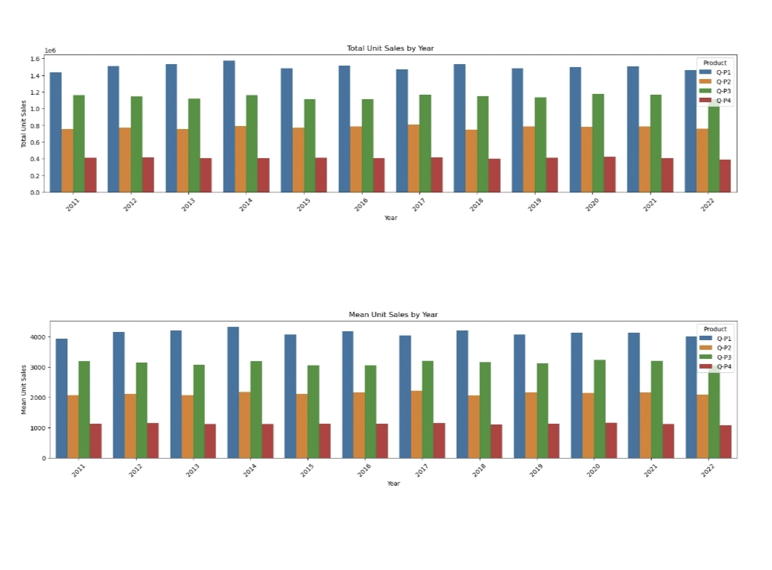

**Observation:**

We can observe that P1 has the highest unit sales for each year. And it's highest is in year 2014.

**We can observe taht P4 has the lowest unit sales of all the products.**

Graph our TOTAL & MEAN revenue of sales for each product using a historgram.

**IN:**

plot_bar_chart(data_reduced, ['S-P1', 'S-P2', 'S-P3', 'S-P4'], 'Total Revenue', 'Year', 'sum')

plot_bar_chart(data_reduced, ['S-P1', 'S-P2', 'S-P3', 'S-P4'], 'Mean Revenue', 'Year', 'mean')

**OUT:**

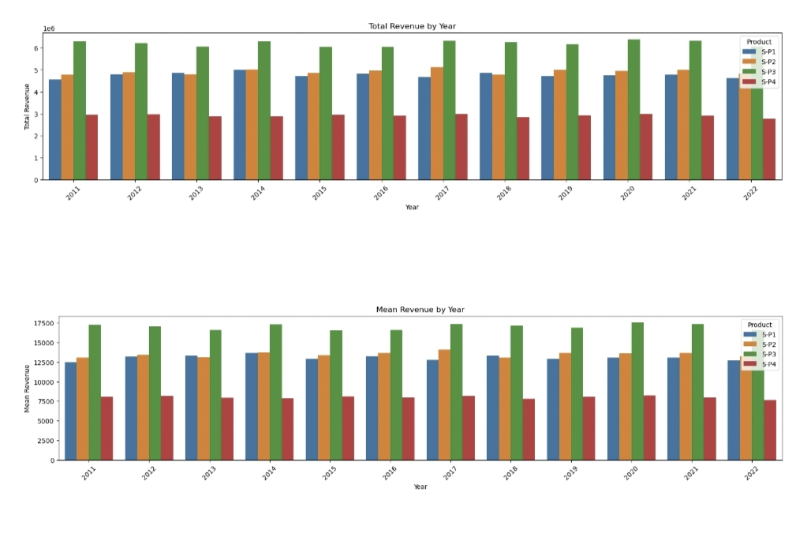

**Observation:**

We can observe that P3 brought in the most revenue. This could be as a result of multiple things:

P3 was sold for higher than the rest, as it had the second highest unit sales for each P1 despite having the most unit sold, brought in the second lowest revenue each year.

**Trend in sales of all four products during certain months**

**IN:**

def month_plot():

fig, ax = plt.subplots()

data_reduced.groupby('Month')[['Q-P1', 'Q-P2', 'Q-P3', 'Q-P4']].sum().plot(ax=ax)

ax.set_xlim(left=0, right=13)

ax.set_xlabel('Month')

ax.set_ylabel('Total unit sales')

ax.set_title('Trend in sales of all four products by month')

plt.show()

month_plot()

**OUT:**

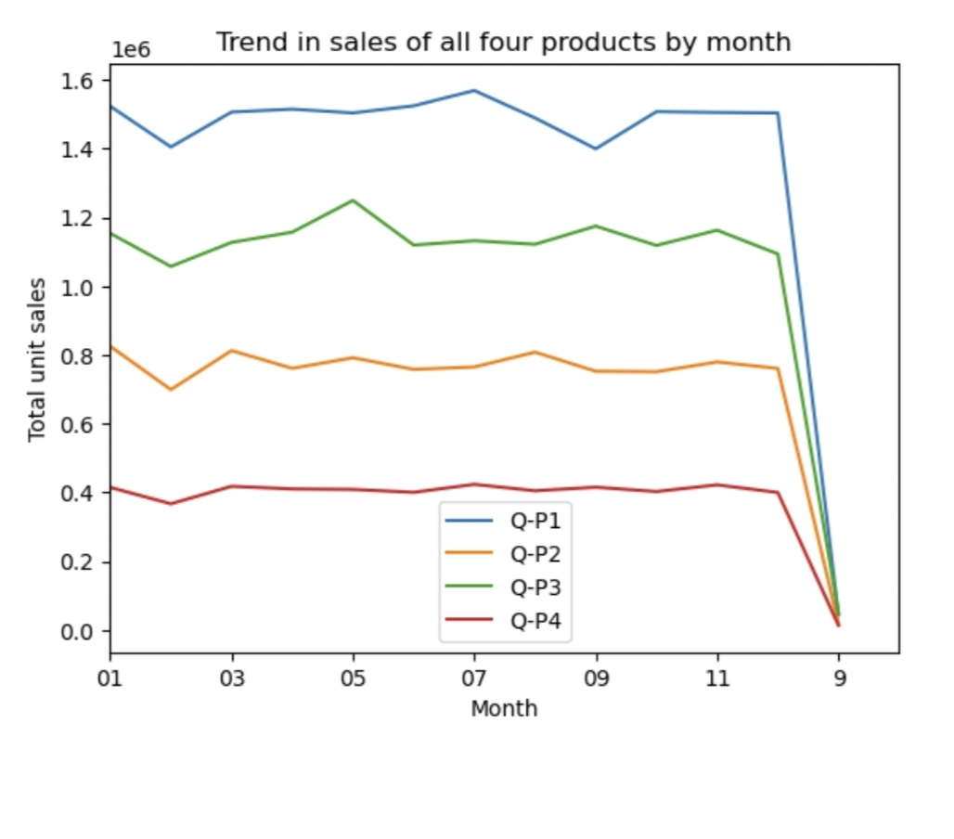

**Observation**

* We can observe that all products drop in Feb.
* There also appears a very drastic drop after 12th month. The value show 9, which must be part of month 09. We need to rename this column to match with the 09. Before doing further analysis.

In [14]:

*# Replace all entries of '9' in the Month column with '09'*

data_reduced['Month'] = data['Month'].replace('9', '09')

In [15]:

month_plot()

**out:**

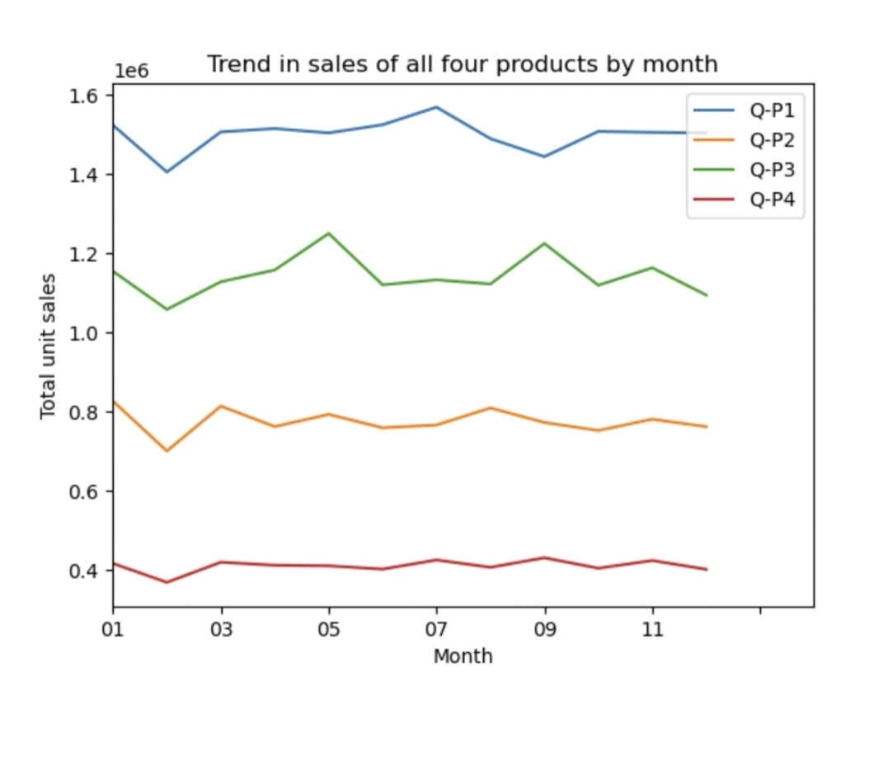

**Observation**

Estimate for each product the unit of sales that could be sold on 31st of Dec, if all their retail centers were kept open.

**Question**

* The company has all it's retail centers closed on the 31st of December every year. Mr: Hariharan , the CEO , would love to get an estimate on no: of units of each product that could be sold on 31st of Dec , every year , if all their retail centers were kept open.

In [16]:

*#get the 31st day for each month in each year. Note: not every month has 31 days*

def month_31_data(df, months):

m31_data = df[df['Month'].isin(months) & (df['Day'] == '31')]

return m31_data

_31_months = month_31_data(data_reduced, ['01', '02', '03', '04', '05', '06', '07', '08', '09', '10', '11', '12'])

_31_months

Out[16]:

|  | Date | Q-P1 | Q-P2 | Q-P3 | Q-P4 | S-P1 | S-P2 | S-P3 | S-P4 | Day | Month | Year |
| --- | --- | --- | --- | --- | --- | --- | --- | --- | --- | --- | --- | --- |
| 231 | 31-01-2011 | 939 | 3325 | 1863 | 1612 | 2976.63 | 21080.50 | 10097.46 | 11493.56 | 31 | 01 | 2011 |
| 290 | 31-03-2011 | 464 | 2220 | 421 | 1663 | 1470.88 | 14074.80 | 2281.82 | 11857.19 | 31 | 03 | 2011 |
| 351 | 31-05-2011 | 1507 | 2980 | 3816 | 1202 | 4777.19 | 18893.20 | 20682.72 | 8570.26 | 31 | 05 | 2011 |
| 412 | 31-07-2011 | 4336 | 744 | 4717 | 667 | 13745.12 | 4716.96 | 25566.14 | 4755.71 | 31 | 07 | 2011 |
| 442 | 31-08-2011 | 4548 | 1484 | 1596 | 1974 | 14417.16 | 9408.56 | 8650.32 | 14074.62 | 31 | 08 | 2011 |
| ... | ... | ... | ... | ... | ... | ... | ... | ... | ... | ... | ... | ... |
| 4352 | 31-05-2022 | 3669 | 2710 | 3067 | 1593 | 11630.73 | 17181.40 | 16623.14 | 11358.09 | 31 | 05 | 2022 |
| 4413 | 31-07-2022 | 1437 | 833 | 1867 | 1270 | 4555.29 | 5281.22 | 10119.14 | 9055.10 | 31 | 07 | 2022 |
| 4443 | 31-08-2022 | 1035 | 1639 | 3658 | 841 | 3280.95 | 10391.26 | 19826.36 | 5996.33 | 31 | 08 | 2022 |
| 4474 | 31-9-2022 | 6964 | 1873 | 5481 | 1336 | 22075.88 | 11874.82 | 29707.02 | 9525.68 | 31 | 09 | 2022 |
| 4535 | 31-11-2022 | 4600 | 2006 | 3796 | 1426 | 14582.00 | 12718.04 | 20574.32 | 10167.38 | 31 | 11 | 2022 |

84 rows × 12 columns

In [17]:

plot_bar_chart(_31_months, ['Q-P1', 'Q-P2', 'Q-P3', 'Q-P4'], 'Average Units', 'each Month, for 31st', 'mean')

**Out:**

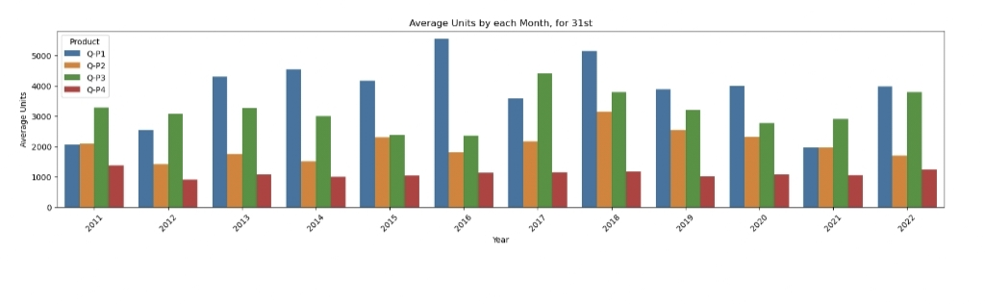

In [18]:

plot_bar_chart(_31_months, ['S-P1', 'S-P2', 'S-P3', 'S-P4'], 'Average Revenue', 'each Month, for 31st', 'mean')

**Out:**

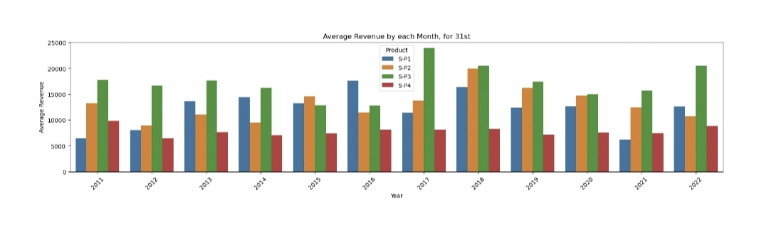

**Observation**

* Overall we can see that P1 has the highest unit sales on the 31st for each year, except for 2021 and 2022. (These could be as a result to Covid and other economy issues.)
* P3 has the second highest unit sales for all the 31st in each year.

In [19]:

*# gives us the average for all the 31st days across all years for each product*

def avg_on_31st(df, product):

df_31 = df[df['Day'] == '31']

avg_sales = df_31[product].mean()

return avg_sales

In [20]:

*# Average for Unit Sales*

avg_on_31st(data_reduced, ['Q-P1', 'Q-P2', 'Q-P3', 'Q-P4']).round(2)

Out[20]:

Q-P1 3813.74

Q-P2 2058.80

Q-P3 3183.88

Q-P4 1098.61

dtype: float64

In [21]:

*# Average for Revenue*

avg_on_31st(data_reduced, ['S-P1', 'S-P2', 'S-P3', 'S-P4']).round(2)

Out[21]:

S-P1 12089.55

S-P2 13052.78

S-P3 17256.63

S-P4 7833.07

dtype: float64

**Observation**

* We can see that our previous observation correlate as Q-P1 has the higest estimate, follwed by Q-P3
* We can approxiamte that the company will make:
  + Q-P1: 3813.74
  + Q-P2: 2058.80
  + Q-P3: 3183.88
  + Q-P4: 1098.61

linkcode

Conclusion

Unit Sales 2011 - 2022

* P1 has the highest unit sales for each year. And it's highest is in year 2014.
* We can observe that P4 has the lowest unit sales of all the products.

Revenues 2011 - 2022

* We can observe that P3 brought in the most revenue. This could be as a result of multiple things:
  + P3 was sold for higher than the rest, as it had the second highest unit sales for each year.
* We can observe than P1 and P2 brought in similar revenues for each year. With P2 bringing in slightly more.
* P1 despite having the most unit sold, brought in the second lowest revenue each year.

Average Month Sales 2011 - 2022

* We can observe that all Products unit sales drop in Feb.
* We can observe that Feb and Dec have the lowest sales for each product
* For P1 We can observe Mar - Jul having the highest unit sales
* For P2 We can observe Jan, Mar - Aug having the highest unit sales
* For P3 We can observe May & Sep having the highest unit sales
* For P4 We can observe uniform sales from Jan - Dec

Estimated Unit Sales for 31st of Dec

This value can not be properly estimated with out Machine Learning. Currently we used the average for all the 31st days across all years for each product.

* Overall we can see that P1 has the highest unit sales on the 31st for each year, except for 2021 and 2022. (These could be as a result to Covid and other economy issues.)
* P3 has the second highest unit sales for all the 31st in each year.
* We can see that our previous observation correlate as Q-P1 has the higest estimate, followed by Q-P3
* We can approxiamte that the company will make:
  + Q-P1: 3813.74
  + Q-P2: 2058.80
  + Q-P3: 3183.88
  + Q-P4: 1098.61